Appendix
Generically, only accepts ’s offer of if and only if (iff) , or
, (1)
which is equivalent to
. (2)
However, the precise value of depends upon ’s type, and thus so too does ’s willingness to accept. More formally, when , accepts iff , where
, (3)
and when , accepts iff , where
. (4)
Let us now turn to ’s choice of . Note that can readily infer that
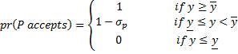 . (5)
Therefore,
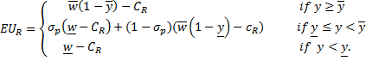 (6)
Note that never profits from setting any larger than necessary to secure a given probability of acceptance from That is, is strictly greater than and that is strictly greater than . What remains is to determine whether pefers to set exactly to , exactly to or less than . Naturally, if does not intend to secure P’s support, then the actual value of y makes no difference. For simplicity, we will assume that R offers nothing (i.e. sets ) in such cases. From above, it follows that holds iff
, (7)
which is equivalent to
. (8)
This simplifies to
, (9)
which can be rewritten as , where
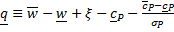 , (10)
holds iff
(11)
which is equivalent to
. (12)
This simplifies to
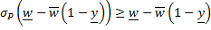, (13)
which is true iff where
. (14)
Observe that is strictly less than since
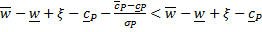 (15)
simplifies to
, (16)
which is true by assumption.
Finally, holds iff
, (17)
which is equivalent to
. (18)
This simplifies to , which we have already defined.
Taken together, this tells us that R sets
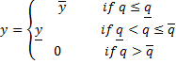 (19)
.
Put differently, case A, as defined in the paper, applies when , while case S applies when , and case N applies when .
Now let us turn to G’s choice of x.
Starting with case A, G can infer that, generically, R accepts iff, which is equivalent to
. (20)
More specifically, R accepts iff when , where
, (21)
and iff when , where
. (22)
Observe that .
Next, consider case S. Here, generically speaking, is equivalent to
. (23)
More specifically, R accepts iff when , where
, (25)
and iff when , where
. (26)
Lastly, consider case N. Here, generically speaking, is equivalent to
. (27)
We can therefore sat that R accepts iff when where
, (27)
and iff when , where
. (28)
Letting and refer generically to the smaller and larger values of and , we can establish that the following results hold across all three cases. First,
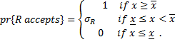 (29)
Second, for the same reason that .
Similarly, is strictly greater than . Put differently, G never offers R better terms than necessary to produce a given probability of acceptance.
Finally, unlike above, we can establish that , since this is generically equivalent to
(30)
which simplifies to
, (31)
a condition that holds for relevant values of w and .
What remains is to determine whether and when G prefers setting , which guarantees acceptance and thus peace, to setting , which risks rejection and thus rebellion.
Begin with case A. Here , iff
. (32)
That holds iff ,where
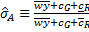 . (33)
Next consider case S. Here iff
. (34)
That holds iff
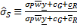 . (35)
Finally, case N, where iff
. (36)
This holds iff , where
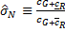 . (37)
We can know full characterize the unique perfect Bayesian equilibrium, which is comprised of the following beliefs and strategies:
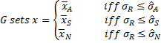 (38)
selecting the corresponding value of otherwise, while
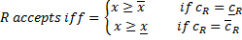, (39)
rejecting otherwise and
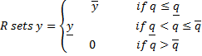, (40)
and
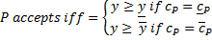, (41)
rejecting otherwise.
Our key results follow from the relative ordering of and , the likelihood that q lies above either or , and the impact of q on and .
Considering first the size of relative to , where holds iff
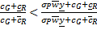. (42)
This holds so long as , since . Intuitively, if we add some arbitrary constant to both the numerator and the denominator of the fraction, the fraction moves closer to 1. Since is essentially with an arbitrary constant added to both the numerator and the denominator it must be true that so long as .
Intuitively, this tells us that G risks war under a more restrictive set of values of under case S then case N, provided that . Though we cannot rule out the possibility that since it is possible that , this implies that the only exception to the claim that G risks war under less permissive conditions in case S than case N is when y takes on values such that case N must apply anyway. Put differently, when the price at which R can buy the support of even the less resolved P is negative, and thus offering such terms would leave R strictly worse off than fighting G alone, the range of values of for which G risks war is more permissive if R adopts a strategy that R will not choose to adopt. That is why we said above that for all meaningful parameter values.
By the same argument as above, this must be true so long as . Since is a possibility, and is thus bounded between 0 and 1, and since , and is true by assumption, it follows that must hold. Here, we do not even need the caveat about needing to be positive, though it is of course still true that cases where are fundamentally uninteresting. Having established that and , it follows that .
This tells us that G risks war under more restrictive conditions when there is a possibility that R and P will team up than when there is no potential for a popular rebellion and that G risks war under even more restrictive conditions when R and P are expected to work together for a certainty. Since case N exists when and case A exists when with case S arising when this indicates that the prospects for rebellion are greatest when the general populace's satisfaction with the status quo is highest and are the most difficult to satisfy when the general populace is least satisfied with the status quo.
However, if increases in q were associated with increases in any of the thresholds, the overall relationship between q and the likelihood of rebellion would be non-monotonic, since increases in q would be associated with an increased likelihood of falling under a case in which G faces a stronger incentive to risk rejection, but a weakening of the incentive to risk rejection within any given case. Thus, we now evaluate the effect of q on and .
It is straightforward to establish that . This is unsurprising since does not contain q or any term that themselves contain q. It is also equally straightforward to demonstrate that and . Note that and are both increasing in q. It is through these terms that increases in q act to increase and .
Next consider the effect of g on and . Note that 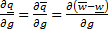, since none of the other components of either and depend in g either directly or indirectly. Since 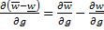, it follows that and decrease in g so long as . This condition holds provided
.
This is equivalent to
, (43)
which ultimately simplifies to .
Finally, consider the effect of g on and . It is straightforward to establish that . Observe that does not contain g or any term that themselves contain g. Note that
contains but that this is multiplied by which has a denominator of . Thus, we can rewrite as 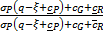. After doing so, it is clear that also does not depend on g. Similarly, contains where also has a denominator of . WE can therefore rewrite as 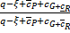, which clearly does not depend on g.
We have therefore shown that increases in q and g increase the likelihood of falling into case S relative to A, and of N relative to S, and that G risks war under more permissive conditions in case S than case A, and under even more permissive conditions in case N. Moreover, increases in q decrease and though g has no impact on the size of or . This establishes that increases in q increase the likelihood that G will risk rejection, as do increases in g, at least provided .

